TIME SERIES ANALYSIS

Time series analysis is a statistical technique that deals with time series data, or trend analysis.  Time series data means that data is in a series of particular time periods or intervals.  The data is considered in three types:

**Time series data:**A set of observations on the values that a variable takes at different times.

|  |  |
| --- | --- |
| Sales of A | Date |
| 3750 | JAN 1999 |
| 3846 | FEB 1999 |
| 3894 | MAR 1999 |
| 4010 | APR 1999 |
| 4147 | MAY 1999 |
| 4335 | JUN 1999 |
| 4554 | JUL 1999 |
| 4744 | AUG 1999 |
| 4885 | SEP 1999 |
| 5020 | OCT 1999 |
| 5208 | NOV 1999 |
| 5379 | DEC 1999 |
| 5574 | JAN 2000 |
| 5828 | FEB 2000 |
| 5942 | MAR 2000 |
| 6139 | APR 2000 |
| 6244 | MAY 2000 |
| 6274 | JUN 2000 |
| 6347 | JUL 2000 |
| 6399 | AUG 2000 |
| 6443 | SEP 2000 |
| 6647 | OCT 2000 |
| 6732 | NOV 2000 |
| 6914 | DEC 2000 |
| 6982 | JAN 2001 |
| 6995 | FEB 2001 |
| 7163 | MAR 2001 |
| 7193 | APR 2001 |
| 7341 | MAY 2001 |
| 7449 | JUN 2001 |
| 7534 | JUL 2001 |
| 7545 | AUG 2001 |
| 7590 | SEP 2001 |
| 7704 | OCT 2001 |
| 7934 | NOV 2001 |
| 8007 | DEC 2001 |
| 8223 | JAN 2002 |
| 8538 | FEB 2002 |
| 8777 | MAR 2002 |
| 8981 | APR 2002 |
| 9074 | MAY 2002 |
| 9321 | JUN 2002 |
| 9582 | JUL 2002 |
| 9754 | AUG 2002 |
| 10103 | SEP 2002 |
| 10414 | OCT 2002 |
| 10455 | NOV 2002 |
| 10515 | DEC 2002 |
| 10602 | JAN 2003 |
| 10713 | FEB 2003 |
| 10771 | MAR 2003 |
| 11015 | APR 2003 |
| 11040 | MAY 2003 |
| 11244 | JUN 2003 |
| 11270 | JUL 2003 |
| 11489 | AUG 2003 |
| 11657 | SEP 2003 |
| 11731 | OCT 2003 |
| 11656 | NOV 2003 |
| 11549 | DEC 2003 |

|  |  |  |
| --- | --- | --- |
| **Case Processing Summary** | | |
|  | | Sales of an employee |
| Series or Sequence Length | | 60 |
| Number of Missing Values in the Plot | User-Missing | 0 |
| System-Missing | 0 |

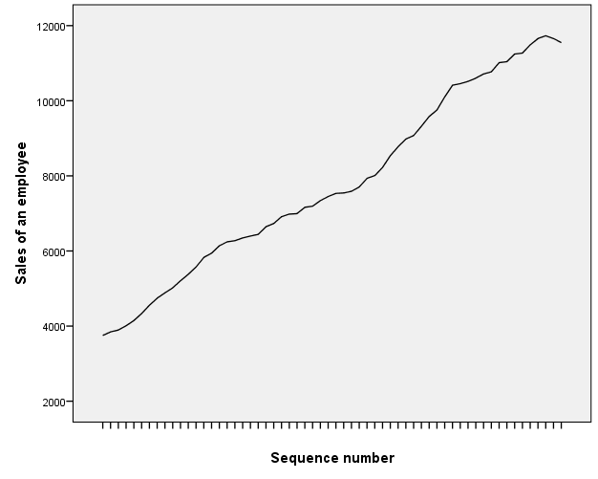After performing sequence chart it is known that the series follow exponential smoothing

|  |  |  |  |  |
| --- | --- | --- | --- | --- |
| Sales of A | Date | Predicted_SalesofA_Model_1 | LCL_SalesofA_Model_1 | UCL_SalesofA_Model_1 |
| 3750 | JAN 1999 | 3819 | 3636 | 4002 |
| 3846 | FEB 1999 | 3808 | 3626 | 3991 |
| 3894 | MAR 1999 | 3916 | 3733 | 4098 |
| 4010 | APR 1999 | 3958 | 3775 | 4140 |
| 4147 | MAY 1999 | 4094 | 3912 | 4277 |
| 4335 | JUN 1999 | 4258 | 4076 | 4441 |
| 4554 | JUL 1999 | 4484 | 4301 | 4667 |
| 4744 | AUG 1999 | 4740 | 4558 | 4923 |
| 4885 | SEP 1999 | 4938 | 4755 | 5120 |
| 5020 | OCT 1999 | 5055 | 4872 | 5238 |
| 5208 | NOV 1999 | 5170 | 4987 | 5353 |
| 5379 | DEC 1999 | 5372 | 5190 | 5555 |
| 5574 | JAN 2000 | 5550 | 5367 | 5732 |
| 5828 | FEB 2000 | 5756 | 5573 | 5938 |
| 5942 | MAR 2000 | 6043 | 5861 | 6226 |
| 6139 | APR 2000 | 6118 | 5936 | 6301 |
| 6244 | MAY 2000 | 6316 | 6134 | 6499 |
| 6274 | JUN 2000 | 6391 | 6208 | 6574 |
| 6347 | JUL 2000 | 6364 | 6181 | 6546 |
| 6399 | AUG 2000 | 6421 | 6238 | 6603 |
| 6443 | SEP 2000 | 6461 | 6278 | 6644 |
| 6647 | OCT 2000 | 6495 | 6313 | 6678 |
| 6732 | NOV 2000 | 6765 | 6582 | 6947 |
| 6914 | DEC 2000 | 6847 | 6665 | 7030 |
| 6982 | JAN 2001 | 7057 | 6874 | 7239 |
| 6995 | FEB 2001 | 7097 | 6914 | 7279 |
| 7163 | MAR 2001 | 7059 | 6877 | 7242 |
| 7193 | APR 2001 | 7265 | 7082 | 7447 |
| 7341 | MAY 2001 | 7272 | 7089 | 7455 |
| 7449 | JUN 2001 | 7445 | 7262 | 7627 |
| 7534 | JUL 2001 | 7560 | 7378 | 7743 |
| 7545 | AUG 2001 | 7634 | 7451 | 7816 |
| 7590 | SEP 2001 | 7603 | 7420 | 7785 |
| 7704 | OCT 2001 | 7635 | 7452 | 7818 |
| 7934 | NOV 2001 | 7779 | 7597 | 7962 |
| 8007 | DEC 2001 | 8082 | 7900 | 8265 |
| 8223 | JAN 2002 | 8134 | 7952 | 8317 |
| 8538 | FEB 2002 | 8384 | 8201 | 8567 |
| 8777 | MAR 2002 | 8773 | 8590 | 8956 |
| 8981 | APR 2002 | 9026 | 8843 | 9208 |
| 9074 | MAY 2002 | 9210 | 9028 | 9393 |
| 9321 | JUN 2002 | 9240 | 9057 | 9423 |
| 9582 | JUL 2002 | 9512 | 9330 | 9695 |
| 9754 | AUG 2002 | 9810 | 9627 | 9992 |
| 10103 | SEP 2002 | 9963 | 9781 | 10146 |
| 10414 | OCT 2002 | 10369 | 10187 | 10552 |
| 10455 | NOV 2002 | 10711 | 10528 | 10893 |
| 10515 | DEC 2002 | 10643 | 10461 | 10826 |
| 10602 | JAN 2003 | 10627 | 10444 | 10809 |
| 10713 | FEB 2003 | 10693 | 10510 | 10876 |
| 10771 | MAR 2003 | 10810 | 10628 | 10993 |
| 11015 | APR 2003 | 10853 | 10670 | 11036 |
| 11040 | MAY 2003 | 11165 | 10983 | 11348 |
| 11244 | JUN 2003 | 11148 | 10966 | 11331 |
| 11270 | JUL 2003 | 11384 | 11202 | 11567 |
| 11489 | AUG 2003 | 11368 | 11185 | 11550 |
| 11657 | SEP 2003 | 11631 | 11448 | 11813 |
| 11731 | OCT 2003 | 11820 | 11637 | 12002 |
| 11656 | NOV 2003 | 11857 | 11674 | 12040 |
| 11549 | DEC 2003 | 11687 | 11504 | 11869 |
|  | JAN 2004 | 11503 | 11321 | 11686 |
|  | FEB 2004 | 11447 | 11126 | 11767 |
|  | MAR 2004 | 11390 | 10910 | 11870 |
|  | APR 2004 | 11333 | 10673 | 11993 |

The predicted value from JAN 2004 to APR 2004 including the upper limit and lower limit is given above

|  |  |  |  |  |  |  |  |  |  |  |  |  |  |
| --- | --- | --- | --- | --- | --- | --- | --- | --- | --- | --- | --- | --- | --- |
| **Model Statistics** | | | | | | | | | | | | | |
| Model | Number of Predictors | Model Fit statistics | | | | | | | | Ljung-Box Q(18) | | | Number of Outliers |
| Stationary R-squared | R-squared | RMSE | MAPE | MAE | MaxAPE | MaxAE | Normalized BIC | Statistics | DF | Sig. |
| Sales of an employee-Model_1 | 0 | .245 | .999 | 91.248 | .958 | 73.955 | 2.441 | 255.229 | 9.095 | 10.663 | 17 | .874 | 0 |

Here the sig >0.05 that is 0.874 so the model is fit